

FLY AWAY PLUS

Screen design

Hanoi, Jun/13/2015

Project Code: FAP

Document Code: FAP_ Screen Design_v1.0_EN

**SIGNATURE PAGE**

AUTHOR: Dương Thanh Hải 13/06/2015

Team member

REVIEWERS: Hoàng Nghĩa Đức 13/06/2015

Project Manager

APPROVAL: Nguyễn Văn Sang --/--/2015

Supervisor

**RECORD OF CHANGE**

*A - Added M - Modified D – Deleted

|  |  |  |  |  |  |
| --- | --- | --- | --- | --- | --- |
| Effective Date | Changed Item | A,M,D | Change Description | Reason for Change | Rev. Number |
| 13/Jun/2015 | Create Screen Design | A |  |  | 1.0 |
| 14/Jun/2015 | Update Screen Design | M |  |  | 1.1 |
|  |  |  |  |  |  |
|  |  |  |  |  |  |
|  |  |  |  |  |  |
|  |  |  |  |  |  |
|  |  |  |  |  |  |
|  |  |  |  |  |  |
|  |  |  |  |  |  |
|  |  |  |  |  |  |
|  |  |  |  |  |  |
|  |  |  |  |  |  |
|  |  |  |  |  |  |
|  |  |  |  |  |  |
|  |  |  |  |  |  |
|  |  |  |  |  |  |
|  |  |  |  |  |  |
|  |  |  |  |  |  |
|  |  |  |  |  |  |
|  |  |  |  |  |  |
|  |  |  |  |  |  |
|  |  |  |  |  |  |
|  |  |  |  |  |  |
|  |  |  |  |  |  |
|  |  |  |  |  |  |
|  |  |  |  |  |  |

# **INTRODUCTION**

## Purpose

To ensure consistency and simplicity in detailed design across all displays within a product interface, as well as across other products used by the same users. Definitions, acronyms, abbreviations, references and overview of FAP website.

## Definitions, Acronyms and Abbreviations

|  |  |  |
| --- | --- | --- |
| Abbreviations | Description | Comment |
| FAP | Fly Away Plus | Social network of travelling |
| Q&A | Question and answer |  |

## Overview

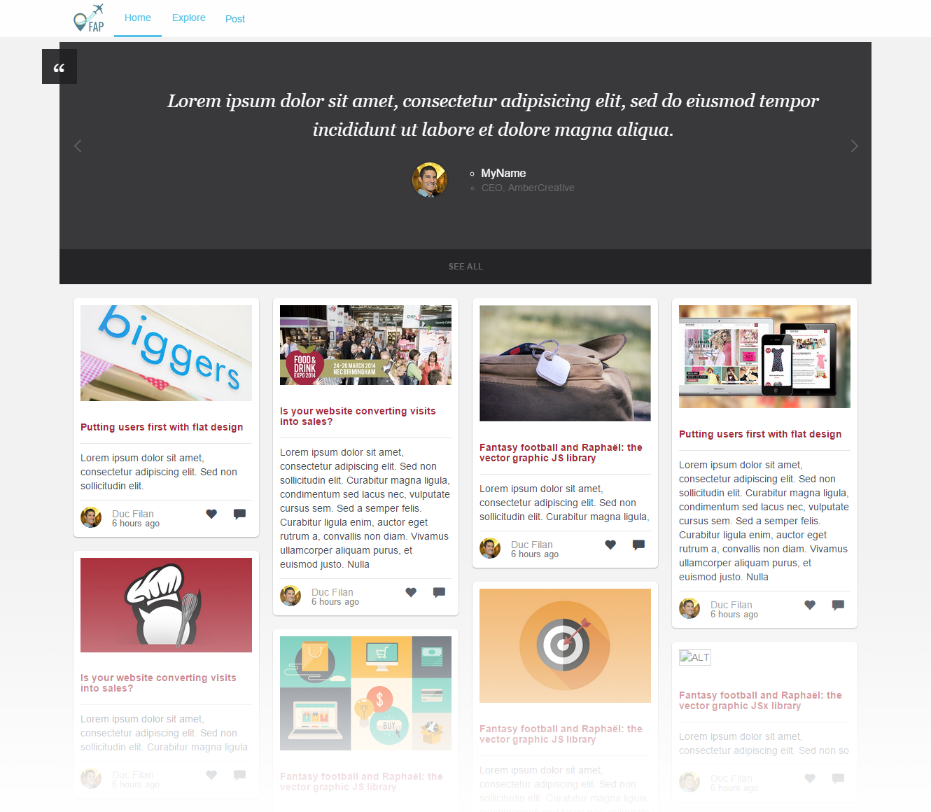

# **SCREEN FLOW**

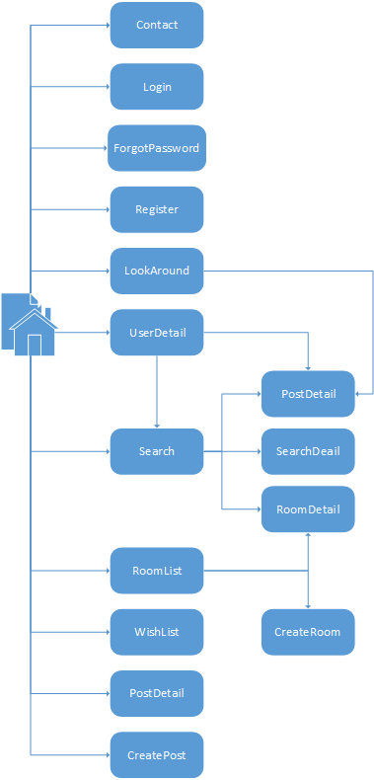

|  |  |  |
| --- | --- | --- |
| No | Screen Name | Description |
| 1 | Homepage | Homepage |
| 2 | Contact | Contact admin |
| 3 | Login | Login as a member |
| 4 | Register | Create New Account |
| 5 | Forgot Password | Get a new password in case of forgetting password |
| 6 | Look Around | Look around current position to find travelling places |
| 7 | User Detail | Timeline and information of user |
| 8 | Search | Search result |
| 9 | Room List | List of rooms |
| 10 | Search Detail | Detail information of a place |
| 11 | Room Detail | Detail information of a room |
| 12 | Post Detail | Detail information of a post |
| 13 | Wish List | List of places to visit in the future |
| 14 | Create Post | Create a post for a place |
| 15 | Create Room | Create a new room |

## Home page



### Figure 1: Home page

|  |  |  |  |  |  |  |  |
| --- | --- | --- | --- | --- | --- | --- | --- |
| No | Field name | Field name in Vietnamese | Type | Require | Mand-atory | Max-Length | Description |
| 1 | Logo | Logo | Image | Image |  |  | Logo of FAP website |
| 2 | Home | Trang chủ | Button | Click | Y |  | Redirect to home page |
| 3 | Post | Đăng bài | Button | Click | Y |  | User want to post a new post |
| 4 | Top Posts | Bài đăng tiêu biểu | Slide |  |  |  | Slide of top posts |
| 5 | Post List | Danh sách bài đăng | List |  |  |  | Show list of post |

## Login

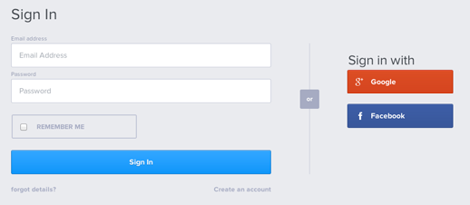

### Figure 2: Login

|  |  |  |  |  |  |  |  |
| --- | --- | --- | --- | --- | --- | --- | --- |
| No | Field name | Field name in Vietnamese | Type | Require | Mandatory | Max-Length | Description |
| 1 | Username | Tên đăng nhập | Text | Text | Y | 32 | User input username with length less than 32 character |
| 2 | Password | Mật khẩu | Password | Text | Y | 32 | User input their password with length less than 32 characters |
| 3 | Sign In | Đăng nhập | Button | Click | Y |  | User click on Sign In button |
| 4 | Sign in with Facebook | Đăng nhập bằng Facebook | Button | Click | Y |  | User click on Facebook button |
| 5 | Sign in with Google | Đăng nhập bằng Google | Button | Click | Y |  | User click on Google button |

## Register

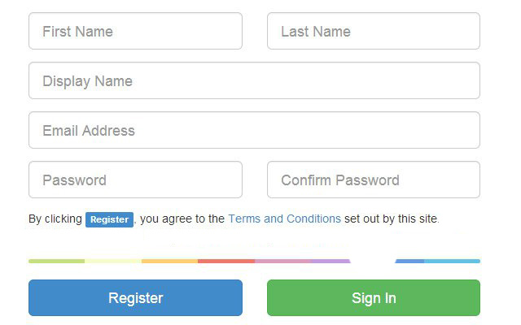

### Figure 3: Register

|  |  |  |  |  |  |  |  |
| --- | --- | --- | --- | --- | --- | --- | --- |
| No | Field name | Field name in Vietnamese | Type | Require | Mandatory | Max-Length | Description |
| 1 | Display Name | Tên đăng nhập | Text | Text | Y | 32 | User input username with length less than 32 characters |
| 2 | Password | Mật khẩu | Password | Text | Y | 32 | User input their password with length less than 32 characters |
| 3 | Confirm password | Nhập lại mật khẩu | Password | Text | Y | 32 | User re-input password with length less than 32 characters |
| 4 | First Name | Tên | Text | Text | Y | 34 | User input their first name with length less than 34 characters |
| 5 | Last Name | Họ | Text | Text | Y | 17 | User input their last name with length less than 17 characters |
| 6 | Email | Email | Text | Text | Y | 100 | User input email with length less than 100 characters |
| 7 | Register | Đăng ký | Button | Click | Y |  | User click Register button |

## Forgot password

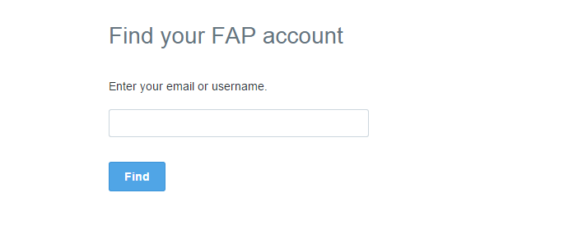

### Figure 4: Forgot password

|  |  |  |  |  |  |  |  |
| --- | --- | --- | --- | --- | --- | --- | --- |
| No | Field name | Field name in Vietnamese | Type | Require | Mandatory | Max-Length | Description |
| 1 | Email | Email | Text | Text | Y | 100 | User input email with length less than 100 characters |
| 2 | Find | Tìm password | Button | Click | Y |  | Click to receive password via email |